DEPARTMENT OF COMPUTER APPLICATION

TKM COLLEGE OF ENGINEERING

KOLLAM – 691005



**20MCA133** – **WEB PROGRAMMING LAB**

PRACTICAL RECORD BOOK

First Semester MCA 2021-2022

**Submitted by:**

NAME: SONI R

ROLL NO: TKM21MCA-2036

DEPARTMENT OF COMPUTER APPLICATION

TKM COLLEGE OF ENGINEERING

KOLLAM – 691005



Certificate

This is a bonafide record of the work done by **SONI R** (TKM21MCA-2036) in the First Semester in Web Programming Lab Course(20MCA133) towards the partial fulfilment of the degree of Master of Computer Applications during the academic year 2021-2022.

Staff Member in-charge Examiner

……………………….. ………………………..

Index

|  |  |  |
| --- | --- | --- |
| Program  No: | programs | Page no: |
|  | **Labcycle 1** |  |
|  | **1.1 Introduction about HTML** |  |
| 1 | **1.2 Model a simple HTML file to demonstrate the use of different tags 2** | 1 |
| 2 | **1.3. Create a HTML file to link to different HTML page which contains images, tables, and also link within a page.** | 8 |
| 3 | **1.4 Create a HTML page with different types of frames such as floating frame, navigation frame & mixed frame 4** | 15 |
| 4 | **1.5 Analyze CSS by applying the different styles using inline, external & internal style sheets in a HTML file 5** | 21 |
| 5 | **1.6 Demonstrate a registration form using HTML** | 26 |
|  | **Labcycle 2** |  |
|  | **2.1 Introduction to Javascript 6 for every click of a button to change the background color of a HTML page** | 30 |
| 6 | **2.2 Create a HTML page to explain the use of various predefined functions in a string and math object in java script. 7** | 31 |
| 7 | **2.3 Generate the calendar using JavaScript code by getting the year from the user** | 40 |
| 8 | **2.4 Create a HTML registration form and to validate the form using JavaScript code** | 44 |
| 9 | **2.5 Evaluating JavaScript Event Handling** | 48 |
| 10 | **2.6 Create a HTML page to display a new image and text when the mouse comes over the existing content in the page using JavaScript Event Handling 11** | 51 |
| 11 | **2.7 Create a HTML page to show online exam using JavaScript** | 54 |
|  | **Labcycle 3** |  |
|  | **3.1 Introduction to PHP & MySQL 12** | 59 |
| 12 | **3.2 Develop a PHP program to connect to a database and retrieve data from a table and show the details in a neat format.** | 61 |
|  | **Labcycle 4** |  |
| 13 | **4.1 Outline a registration form using PHP and do necessary validations Compose Electricity bill from user input based on a given tariff using PHP. 14** | 67 |
| 14 | **4.2 Compose Electricity bill from user input based on a given tariff using PHP. 15** | 73 |
| 15 | **4.3 Build a PHP code to store name of students in an array and display it using print_r function. Sort and Display the same using asort & arsort** | 79 |
| 16 | **4.4 Build a PHP code to store name of Indian Cricket players in an array and display the same in HTML table** | 81 |
|  | **Labcycle 5** |  |
| 17 | **5.1 Develop Web applications using HTML and PHP and deploy.** |  |
| 18 | **5.2 Using PHP and MySQL, develop a program to accept book information viz. Accession number, title, authors, edition and publisher from a web page and store the information in a database and to search for a book with the title specified by the user and to display the search results with proper heading** | 83 |
| 19 | **5.3 Develop a registration form using any PHP framework (Laravel, CodeIgniter, Symfony, CakePHP etc.)** |  |

HTML (HYPERTEXT MARKUP LANGUAGE)

HTML is the language for publishing web pages on the WWW .It is a Document Description Language. HTML is NOT a programming language like C/C++/C#/Java, which is used to implement programming algorithm

An HTML element is defined by a start tag, some content, and an end tag:Content goes here.. The HTML element is everything from the start tag to the end tag:

<h1>my heading</h1>

<p> My first paragraph</p>

HTML tables allow web developers to arrange data into rows and columns. The tag defines an HTML table.e. Each table row is defined with a tag. Each table header is defined with a tag. Each table data/cell is defined with a tag. By default, the text in elements are bold and

centered. By default, the text in elements are regular and leftaligned. HTML lists allow web developers to group a set of related items in lists. HTML lists allow web developers to group a set of related items in lists. An ordered list starts with the tag. Each list item starts with the tag. The list items will be marked with numbers by default.HTML also supports description lists. A description list is a list of terms, with a description of each term.The tag defines the description list, the tag defines the term (name), and the tag describes each term.

An HTML form is used to collect user input. The user input is most often sent to a server for processing The HTMLTop of Formelement is used to create an HTML form for user input.TheTop of Formelement is a container for different types of input elements, such as: text fields, checkboxes, radio buttons, submit buttons, etc., depending on the type attribute. The tag defines a label for many form elements. The defines a radio button. The defines a checkbox. Checkboxes let a user select ZERO or MORE options of a limited number of choices. The defines a button for submitting the form data to a form-handler. The form-handler is typically a file on the server with a script for processing input data. The formhandler is specified in the form's action attribute

CSS (CASCADING STYLE SHEET)

Cascading Style Sheets (CSS) is a style sheet language used for describing the presentation of a document written in a markup language such as HTML. CSS is a cornerstone technology of the World Wide Web, alongside HTML and JavaScript.

CSS is designed to enable the separation of presentation and content, including layout, colors, and fonts. This separation can improve content accessibility, provide more flexibility and control in the specification of presentation characteristics, enable multiple web pages to share formatting by specifying the relevant CSS in a separate .css file which reduces complexity and repetition in the structural content as well as enabling the .css file to be cached to improve the page load speed between the pages that share the file and its formatting.

There are 3 ways to implement CSS in a HTML Page, they are :

1.INLINE CSS

2.INTERNAL CSS

3.EXTERNAL CSS

**PROGRAM NO:1**

**AIM**: Model a simple HTML file to demonstrate the use of different tags

**Design:** 1. Create an html page containing different tags.

2. Create a CSS file for styling.

**Source code**

|  |  |
| --- | --- |
| pgm1-co1.html | <html>  <head>  <title>my college</title>  <body bgcolor="black"text="white">  <h1><center>Tkm college ofengineering</center></h1>  <h2><center>mca<i>2021-2023</i></center></h2>  <hr width="15%">  <h2><u>subjects</u></h2>  <ul type="square">  <li><font color="cyan">advanced software engineering</font></li>  <li><font color="cyan">advanced data structure</font></li>  <li><font color="cyan">digital fundamentals and computer architecture</font></li>  <li><font color="cyan">mathematical computing</font></li>  </ul>  <h2><u>lab</u></h2>  <ul type="disc">  <li>web programming lab</li>  <li>data structure</li>  <li>python</li>  </ul>  <h2><li><font color="cyan"><b><u>advanced software engineering</u></b></font></li></h2>  <p><b><u>preamble-</u></b><em>  Most of the programs on Computer Applications do not give due importance to teach Software Engineering in an Industry perspective. But this course, built upon the tools and techniques prevalent in Industry today, is supposed to make students Industry-ready  </em></p>  <h2>course level assessment questions</h2>  <b>course outcome:1</b>  <ol type="a">  <li><i> Understand the software development as an engineering process and its stages</i></li>    <li><i>Understand Software development lifecycle (SDLC)<i></li>  <li><i>Understand software engineering models<i></li>  </ol>  <b>Course Outcome :2 (CO2)</ol>  <ol type="a">  <li><i>Understand writing industry-grade software programs, following style guides and coding  standards.<i></li>  <li><i>Learn core concepts of software version control system and common operations with Git distributed version control system.<i></li>  <li><i>Understanding software quality concepts with respect to software requirement specifications document, what to conform to at various stages of SDLC<i></li>  <li><i>Understand what to ensure at various stage of SDLC to ensure quality of developed software system<i></li>  </ol>  <h2><font color="cyan"><b><u>advanced data structure</u></b></font></h2>  <p><b><u>preamble:</u></b><em>A graduate course in Computer Applications should give due exposure to the recent developments. Since Data structures is a central pillar of any program on Computer Science/ Applications, this course is designed to build upon the knowledge acquired at the undergraduate level and familiarise students with a bunch of modern data structures which are quite useful to solve, in the most effective manner, the modern, real life problems. </em>  </p>  <b>Course Outcomes:</b>  <ol type="a">  <li>Remember the Basic Data Structures and understand the Set Data Structure and  implementation.</li>  <li>Understand Advanced Heap Structures suitable for solving Computational problems  involving Optimisation and analysing these data structures using amortised analysis.</li>  <li>Understand the basic operation of Blockchaining along with the data structures used in  it and the challenges in Blockchain data. </li>  </ol>  <h2><font color="cyan"><b><u>digital fundamentals and computer architecture</u></b></font></h2>  <p><b><u>preamble:</u>The primary aim of this course is to understand the fundamentals behind the digital logic design and gain the experience to design digital circuits and systems. Students should also acquire some understanding and appreciation of a computer system’s functional components, their  characteristics, performance and interactions. They need to understand the computer architecture  in order to make best use of the software tools and computer languages they use to create programs.</b></p>  <b>course outcomes:</b>  <ol type="a">  <li>Apply the basics of digital electronics to design and realize simple combinational  logic circuits</li>  <li>Apply the digital electronics principles to design sequential logic circuits</li>  <li>Understand and different types of memories - RAM, ROM, Cache memory, virtual</li>  </ol>  <h2><fontcolor="cyan"><b><u>mathematical computing</u></font></h2>  <p><b><u>preamble:</u>This course introduces students to some basic mathematical ideas and tools which are at the core of MCA course. It introduces the concepts of graph theory, set theory and statistic</b></p>  <ol tpe="a">  <li>Understand mathematical reasoning in order to read, comprehend and construct mathematical a</li>  <li>Count or enumerate objects and solve counting problems and analyze algorithms</li>  <li>Solve problems in almost every conceivable discipline using graph model</li>  </ol>  </body>    </head>  </html |
|  |  |

**Output:**



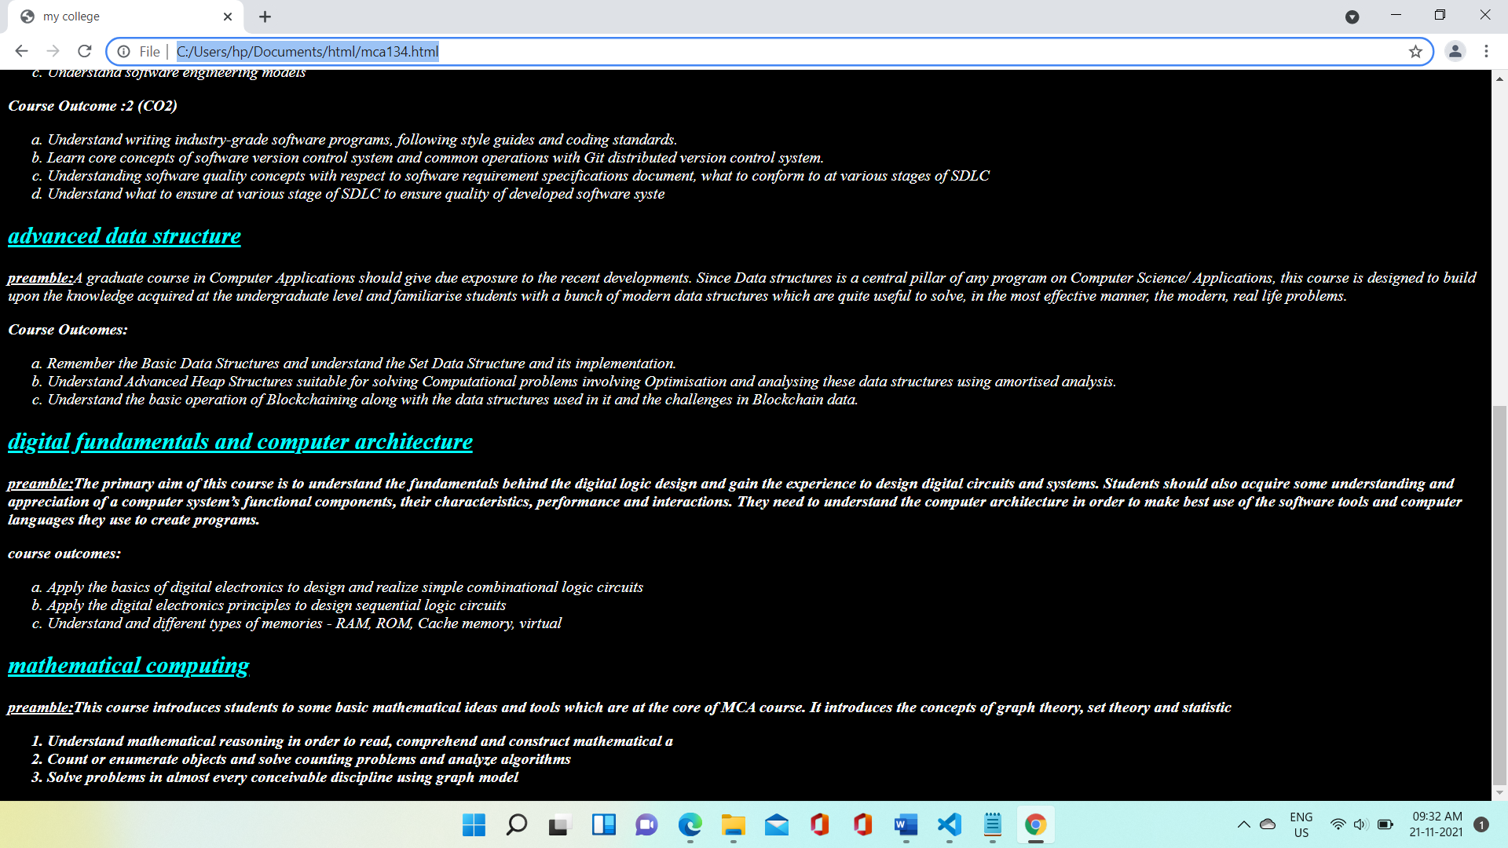

**RESULT:**

Program was successfully executed and output obtained successfully*.*

**PROGRAM NO:2**

**AIM:** Create a HTML file to link to different HTML page which contains images, tables, and also link within a page

**Design:**

1. Create an html page containing your basic information’s.

2. Create an html page containing your academic information’s.

3. Create an html page containing your contact details.

4. Create a CSS file for styling.

**Source code**

|  |  |
| --- | --- |
| Resume.html | <html>  <head>  <style>  body  {background-color:lightblue;}  h1{text-align:center}  .center{text-align:center;}  table{background-color:yellow;}  </style>  </head>  <body>  <h1>MY RESUME</h1>  <center><img src="soni.jpg" width="20%" height="40%"></center>  <table align="center" border color="black" width="70%" height="50">  <tr>  <td><a href="resume.html">general information</a></td>  <td><a href="ad.html">academic details</a></td>  <td><a href="cd.html">contact details</a></td>  </tr>  </table>  <table border="2" align="center" height="20%" width="70%">  <tr>  <td>name</td>  <td>Soni.R</td>  </tr>  <tr>  <td>age</td>  <td>-</td>  </tr>  <tr>  <td>sex</td>  <td>female</td>  </tr>  <tr>  <td>nationality</td>  <td>indian</td>  </tr>  <tr>  <td>dob</td>  <td>20/07/1999</td>  </tr>  <tr>  <td>Religion</td>  <td>christianity</td>  </tr>  <tr>  <td>Blood group</td>  <td>o++</td>  </tr>  <tr>  <td>department</td>  <td>MCA</td>  </tr>  </table>  </body  </html> |

|  |  |
| --- | --- |
| Contact details.html | <html>  <head>  <title>contact details</title>  <style>  body{background:lightcyan}  h1{text-align:center;color:red;}  table{background-color: yellow;}    </style>  </head>  <body>  <h1>contact details</h1>  <table border="black" cell spacing="2%" width="30%" cell padding="2%" align="center" backgroundcolor="">  <tr>  <td>phone numbr</td>  <td>-----</td>  </tr>  <tr>  <td>email id</td>  <td>------</td  </tr>  <tr>  <td>address</td>  <td>------</td>  </tr  </table>  </body>  </html> |

|  |  |
| --- | --- |
| **Academic.html** | **<html>**  **<head>**  **<title>academic details</title>**  **<style>**  **body{background-color: lightpink;}**  **table{background-color: lightslategray;}**  **</style>**  **</head>**  **<body>**  **<h1 align="center">Academic deatails</h1>**  **<table border="black" cell spacing="2%" width="70%" cell padding="2%" align="center">**  **<tr>**  **<td><a href="GI.html">general information</a></td>**  **<td><a href="ad.html">academic details</a></td>**  **<td><a href="cd.html">contact details</a></td>**  **</tr>**  **<tr>**  **<td>graduation</td>**  **<td>bsc chemistry<br>(2018-2021)</td>**  **</tr>**  **<tr>**  **<td>plus tw0</td>**  **<td>HSE</td>**  **</tr>**  **</table>**  **</body>**  **</html>** |

**Output:**

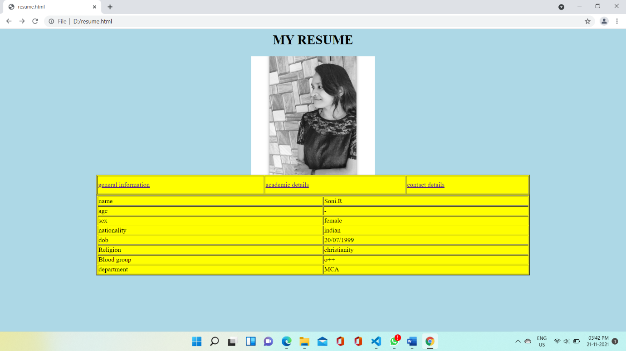

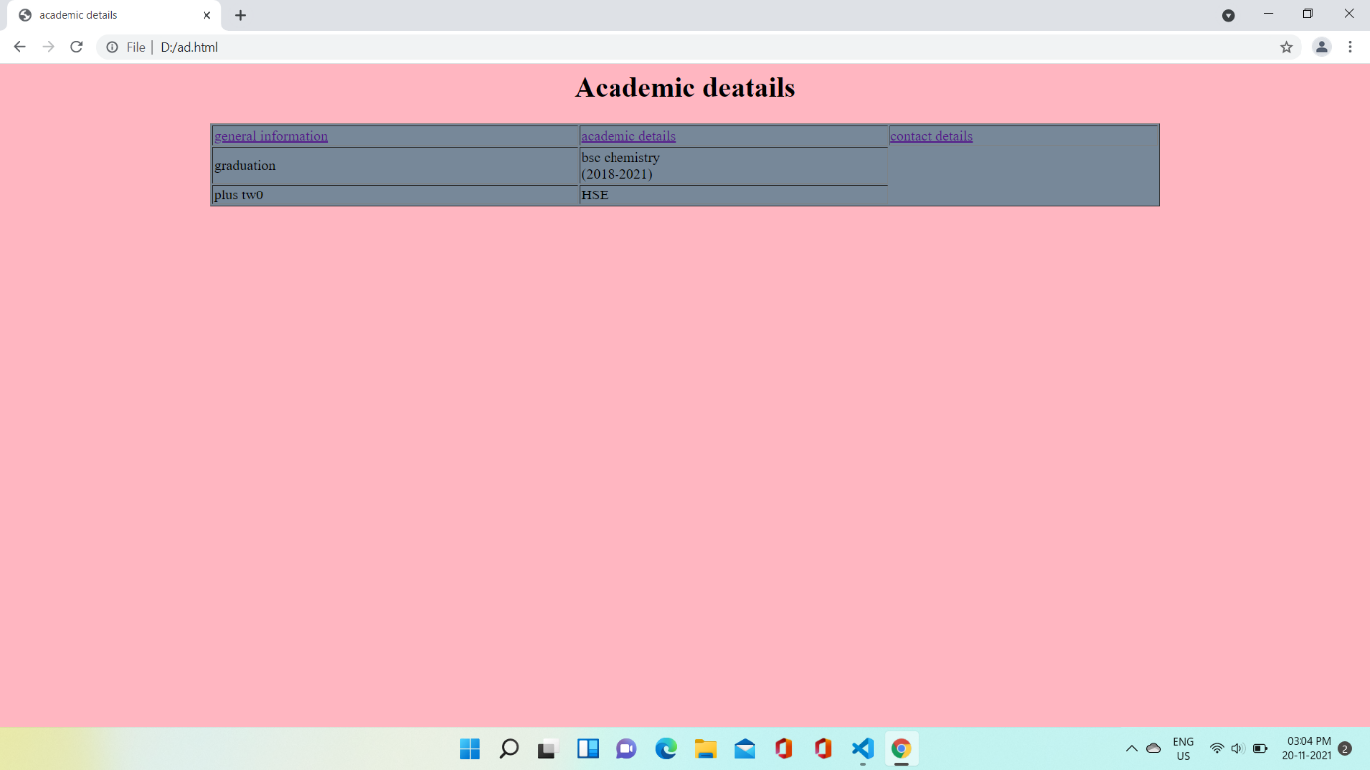

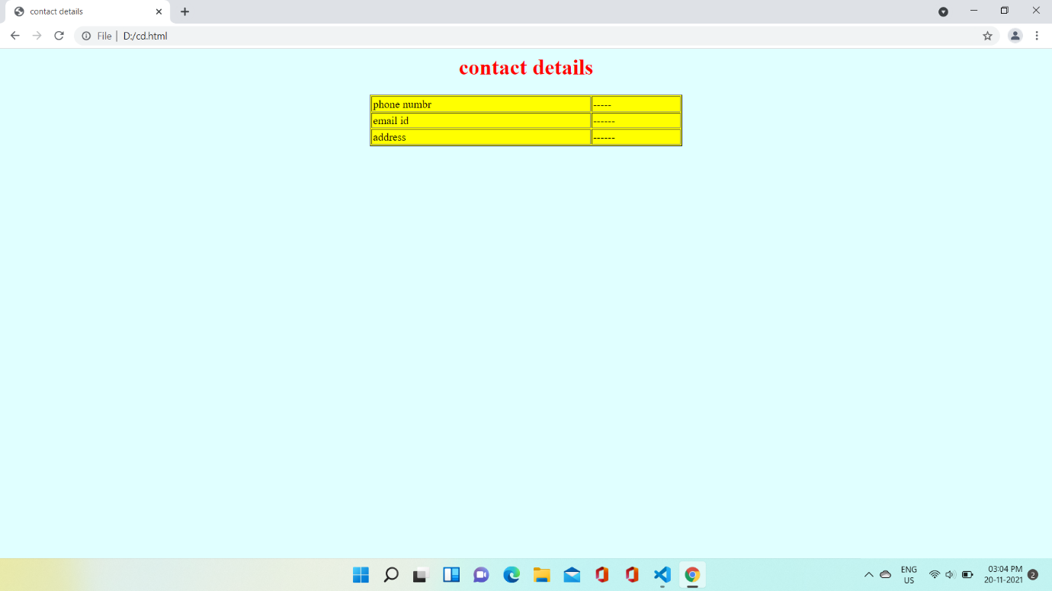

**RESULT:**

Program was successfully executed and output obtained successfully*.*

**PROGRAM NO:3**

**AIM:** Analyze CSS by applying the different styles using inline, external & internal style sheets in a HTML file.

**Design**:

1. Create an html page containing floating frames.
2. Create an html page containing navigation frames.
3. Create an html page containing mixed frames.
4. Create a CSS file for styling.

**Source code**

|  |  |
| --- | --- |
| Frames.html | <html>  <head>  <title>My college</title>  <style>  frame{  background-color: yellow;  }  </style>    </head>  <frameset cols="20%,50%">  <frame name="menubar" src="menubar1.html" >  <frame name="main" src="newpage1.html" >  </frameset>  </html> |

|  |  |
| --- | --- |
| Menubar1.html | <html>  <head>  <title>let try it</title>  <body>  <div class="navbar">  <a href="newpage1.html" target="main" class="nav">home</a><br>  <a href="iframe.html" target="main" class="nav">floating frames</a><br>  <a href="navigation.html" target="main" class="nav">navigation frames</a><br>  <a href="mixed3.html" target="main" class="nav">mixed frame3</a>  </body>  </head>  </html> |

|  |  |
| --- | --- |
| Newpage1.html | <html>  <head>  <title>my document</title>  <style>  body{  background-color: violet;  }  </style>  </head>  <body>  <p<b>your content to be diplayed</b></p>  </body></html> |
| Iframe.html | <html>  <head>  <style>  h1{ text-align:center;  color:red;}  body{background-color:linen  }  </style>  <title>TKM college of engineering kollam</title>  </head>  <body>  <h1>TKM college of engineering</h1>  <iframe src="https://www.tkmce.ac.in" width="100%" height="50%"></iframe>  </body>  </html> |

|  |  |
| --- | --- |
| Navigation.html | <html>  <head>  <title>my document</title>  </head>  <frameset cols="20%,80%">  <frame name="navbar"src="navbar.html"></frame>  <frame name="main"></frame>  </frameset>  </html> |

|  |  |
| --- | --- |
| Navbar.html | <html>  <head>  <style>  div{  border:1px solid black  }  </style>  </head>  <body>  <a href="http://tkmce.ac.in/"target="main"><div name="navbar">TKM college of engineering</div></a>  <a href="https://www.cet.ac.in/"target="main"><div name="navbar">CET college of engineering</div></a>  </body>  </html> |

|  |  |
| --- | --- |
| Mixed3.html | <html>  <head>  <title>MY DOCUMENT</title>  </head>  <frameset cols="50%,50%">  <frame name="main" src="iframe.html">  <frame name="main" src="navigation.html">  </frameset>  </html> |

**Output:**

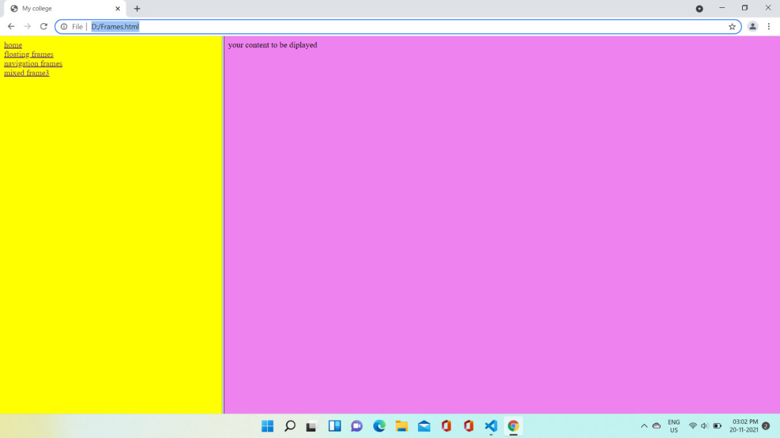



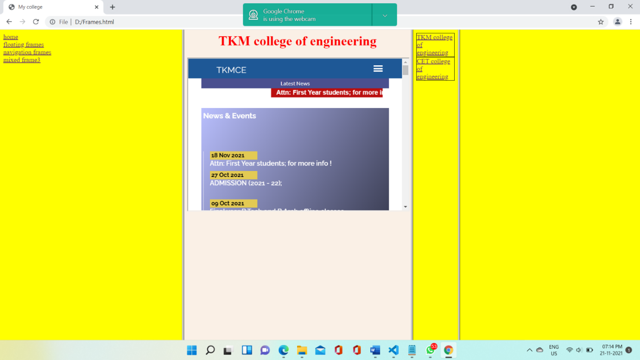

**RESULT:**

The program was successfully executed and output obtained successfully.

**PROGRAM NO:4**

**AIM:** Analyze CSS by applying the different styles using inline, external & internal style sheets in a HTML file*.*

**Design**:

1. Create an html page containing inline and internal CSS.

2. Create a CSS file for styling.

**Source code**

|  |  |
| --- | --- |
| Form2.html | <html>  <head>  <link href="style1.css" rel="stylesheet">  <title>form</title>  <style>  table.center{  justify-content: center;  }  h1{  text-align: center;  color:black;  }  input[type="submit"]:hover{  background-color: rgb(43, 226, 162);  }    </style>  </head>  <body>  <h1><u>Registration form</u></h1>  <form>  <center>  <table>  <tr><td>NAME:</td><td><input type="text" size="10" placeholder="enter your name" border="curved" autofocus="required" style="background-color:yellow;border-width: thick;></td></tr>  <tr><td>LAST NAME:</td><td><input type="text" size="10" autofocus="required" style="background-color: yellow; border-width: thick;"></td></tr>  <tr><td>DOB:</td><td><input type="date" name="d" style="background-color: yellow; border-width: thick;"></td></tr>  <tr><td>ADDRESS:</td><td><textarea name="add" rows="10" cols="50" placeholder="must enter the pincode" style="background-color:yellow; border-width:thick;"></textarea></td></tr><tr><td></td></tr>  <tr><td>E-MAIL:</td><td><input type="e-mail"name="n" placeholder="enter your e-mail" style="background-color:yellow;"></td></tr>  <tr><td>PASSWORD:</td><td><input type="passsword"name="f6" placeholder="enter your password" style="background-color:yellow; border-width: thick;"></td></tr>  <tr><td>PHONE:</td><td><input type="phone number" name="t" placeholder="enter your phone number" style="background-color:yellow ; border-width: thick;"></td></tr>  <tr><td>GENDER:</td><td>MALE<input type="radio" id="html" name="g" value="MALE" style="background-color:yellow; border-width: thick;">  FEMALE<input type="radio" id="html" name="g" value="FEMALE" style="background-color:yellow;"></td></tr>  <tr><td>STATE:</td><td><select name="state" style="background-color:yellow; border-width: thick;">  <option selected= value="default" style="background-color:yellow; border-width: thick;">please select a state</option>  <option value="kerala">kerala</option>  <option value="tamil nadu">tamil nadu</option>  <option value="orissa">orissa</option>  </select></td></tr>  <tr><td>LANGUAGE KNOWN:</td><td><input type="checkbox" name="11" value="m" style="background-color:yellow; border-width: thick;">C++<br>  <input type="checkbox" name="12" value="m1">Java<br>  <input type="checkbox" name="13" value="m2">python<br></td></tr>  <tr><td><input type="submit" name="s" border-width: thick;"></td><td><input type="reset" name="r" style="background-color:yellow ;border-width: thick;"></td></tr>  </table>  </center>  </form>  </body>  </html> |

|  |  |
| --- | --- |
| Style1.css | body{  background:url("soni5.jpg");  background-repeat=no-repeat;  background-size: cover;  text-align: center;  border-style: double;  font-family: Georgia, 'Times New Roman', Times, serif;  font-style: calc();  font-size: 30px;  margin-right: inherit;  background-size: cover;  }  table {  border-style:solid;  border-radius: 10px;  width: 50px;  font-size: 10px;  font-family: Georgia, serif;  background-size: cover;  padding: 30px;  margin: 20px;  }  form{  background-color: rgba(17, 3, 3, 0.115);  border-radius: 30px;  padding:30px;  margin: 70px;} |

**Output:**

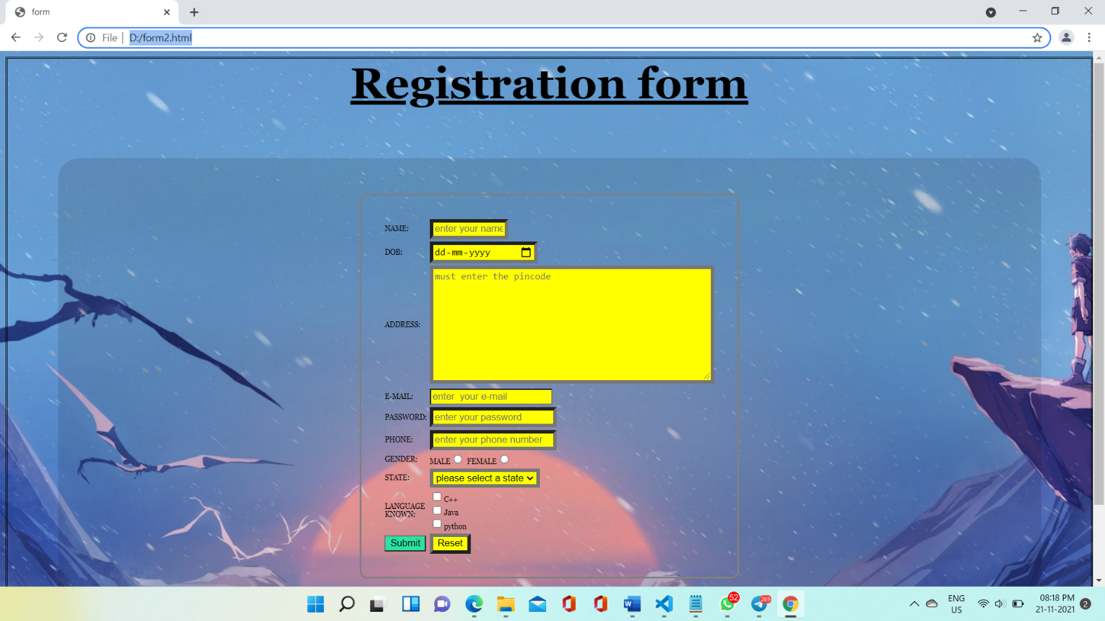

**RESULT:**

The program was successfully executed and output obtained successfully .

**PROGRAM NO:5**

**AIM:** Demonstrate a registration form using HTML*.*

**Design**:

1. Create an html page containing a form.
2. Create a CSS file for styling.

**Source code**

|  |  |
| --- | --- |
| Form.html | <html>  <head>  <title>form</title>  <style>  body{  background:url("soni5.jpg");  text-align: center;  border-style: double;  }  h1{  text-align: center;  color: black;  }  table {  border-style: solid;  width: 50px;  }  table.center{  justify-content: center;  }  form{  background-color: rgba(17, 3, 3, 0.115);  border-radius: 30px;  padding:30px;  margin: 70px;  }  </style>  </head>  <body>  <h1><u>Registration form</u></h1>  <form>  <center>  <table>  <tr><td>NAME:</td><td><input type="text" size="10" placeholder="enter your name" border="curved" autofocus="required" style="background-color: yellow;border-width: thick;></td></tr>  <tr><td>LAST NAME:</td><td><input type="text" size="10" autofocus="required" style="background-color: yellow; border-width: thick;"></td></tr>  <tr><td>DOB:</td><td><input type="date" name="d" style="background-color: yellow; border-width: thick;"></td></tr>  <tr><td>ADDRESS:</td><td><textarea name="add" rows="10" cols="50" placeholder="must enter the pincode" style="background-color:yellow; border-width: thick;"></textarea></td></tr><tr><td></td></tr>  <tr><td>E-MAIL:</td><td><input type="e-mail"name="n" placeholder="enter your e-mail" style="background-color:yellow;"></td></tr>  <tr><td>PASSWORD:</td><td><input type="passsword"name="f6" placeholder="enter your password" style="background-color:yellow; border-width: thick;"></td></tr>  <tr><td>PHONE:</td><td><input type="phone number" name="t" placeholder="enter your phone number" style="background-color:yellow; border-width: thick;"></td></tr>  <tr><td>GENDER:</td><td>MALE<input type="radio" id="html" name="g" value="MALE" style="background-color:yellow; border-width: thick>FEMALE<input type="radio" id="html" name="g" value="FEMALE" style="background-color:yellow;"></td></tr>  <tr><td>STATE:</td><td><select name="state" style="background-color:yellow; border-width: thick;">  <option selected= value="default" style="background-color:yellow; border-width: thick;">please select a state</option>  <option value="kerala">kerala</option>  <option value="tamil nadu">tamil nadu</option>  <option value="orissa">orissa</option>  </select></td></tr>  <tr><td>LANGUAGE KNOWN:</td><td><input type="checkbox" name="11" value="m" style="background-color:yellow; border-width: thick;">C++<br>  <input type="checkbox" name="12" value="m1">Java<br>  <input type="checkbox" name="13" value="m2">python<br></td></tr>  <tr><td><input type="submit" name="s" style="background-color:yellow; border-width: thick;"></td><td><input type="reset" name="r" style="background-color:yellow ;border-width: thick;"></td></tr>  </table>  </center>  </form>  </body>  </html> |

**Output:**

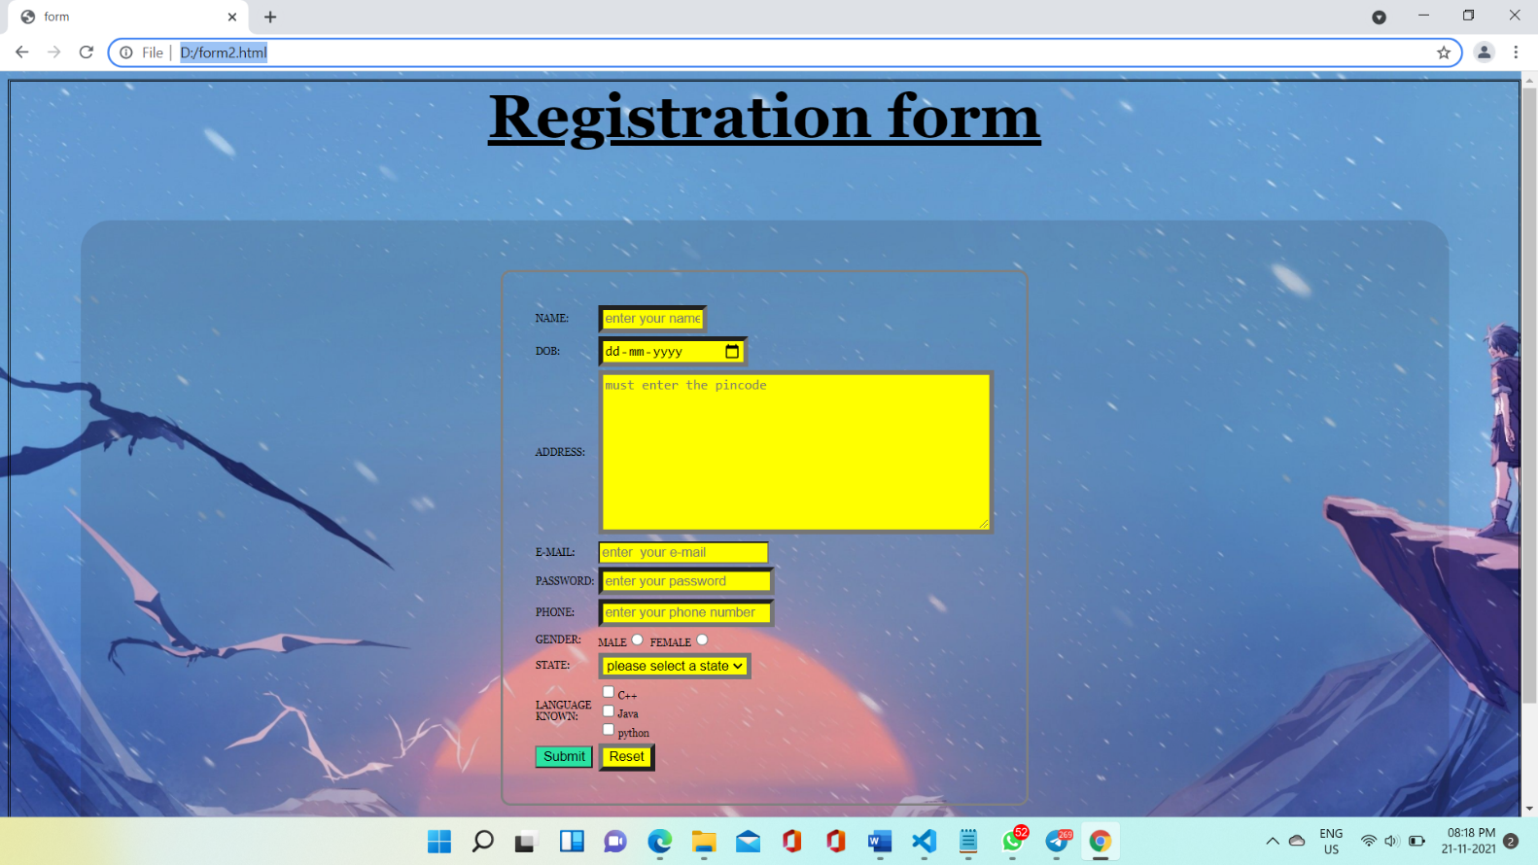

**RESULT**:

The program was successfully executed and output obtained successfully.

JAVASCRIPT

JavaScript often abbreviated JS, is a programming language that is one of the core technologies of the World Wide Web, alongside HTML and CSS. Over 97% of websites use JavaScript on the client side for web page behaviour, often incorporating third-party libraries. All major web browsers have a dedicated JavaScript engine to execute the code on users' devices

JavaScript is a high-level, often just-in-time compiled language that conforms to the ECMAScript standard. It has dynamic typing, prototype-based object-orientation, and firstclass functions. It is multi-paradigm, supporting event-driven, functional, and imperative programming styles. It has application programming interfaces (APIs) for working with text, dates, regular expressions, standard data structures, and the Document Object Model (DOM).

The ECMAScript standard does not include any input/output (I/O), such as networking, storage, or graphics facilities. In practice, the web browser or other runtime system provides JavaScript APIs for I/O.

JavaScript engines were originally used only in web browsers, but are now core components of some servers and a variety of applications. The most popular runtime system for this usage is Node.js

Although Java and JavaScript are similar in name, syntax, and respective standard libraries, the two languages are distinct and differ greatly in design.

**PROGRAM NO:6**

**AIM:** Create a HTML page to explain the use of various predefined functions in a string and math object in java script*.*

**Design:**

1. Create an HTML page containing string functions

2. Create an HTML page containing math functions

**Source code**

|  |  |
| --- | --- |
| string.html | <html>  <head>  <title>string</title>  </head>  <body>  <center>  <a href="string2.html">STRING FUNCTIONS</a><br>  <a href="math1.html">MATH FUNCTIONS</a><br>  <h1>STRING FUNCTIONS</h1>  <table style=background-color:cadetblue>  <tr>  <td>Enter the string</td>  <td></td>  <td><input type=text name="in1" id="in1"></td>  </tr>  <tr>  <td>search the string</td>  <td></td>  <td><input type=text name="in2" id="in2"></td>  </tr>  <tr>  <td>slice the string</td>  <td></td>  <td><input type="number" name="in3" id="in3" placeholder="start"></td>  <td><input type="number" name="in4" id="in4" placeholder="stop"></td>  </tr>  <tr>  <td>replace the string</td>  <td></td>  <td><input type=text name="in5" id="in5"></td>  </tr>  <tr>  <td>enter a uppercase string</td>  <td></td>  <td><input type=text name="in6" id="in6"></td>  </tr>  <tr>  <td>enter a string concat </td>  <td></td>  <td><input type=text name="in7" id="in7"></td>  </tr>  <tr>  <td>enter a string pad</td>  <td></td>  <td><input type=text name="in8" id="in8"></td>  </tr>  <tr>  <td><button type="submit" id="con" onclick="submit()">SUBMIT</button></td>  </tr>  </table>  <table align="center" width="50%" style="background-color:beige" >  <tr>  <td>length of string:</td>  <td><span id="out1"></span></td>  </tr>  <tr>  <td>index of string:</td>  <td><span id="out2"></span></td>  </tr>  <tr>  <td>slice the string:</td>  <td><span id="out3"></span></td>  </tr>  <tr>  <td>substrng of string:</td>  <td><span id="out4"></span></td>  </tr>  <tr>  <td>replace the string:</td>  <td><span id="out5"></span></td>  </tr>  <tr>  <td>uppercase of string:</td>  <td><span id="out6"></span></td>  </tr>  <tr>  <td>lowercase of string:</td>  <td><span id="out7"></span></td>  </tr>  <tr>  <td>concatenated of string:</td>  <td><span id="out8"></span></td>  </tr>  <tr>  <td>padding at beginning of string:</td>  <td><span id="out9"></span></td>  </tr>  <tr>  <td>padding at end of string:</td>  <td><span id="out10"></span></td>  </tr>  <tr>  <td>substring of string:</td>  <td><span id="out11"></span></td>  </tr>  </table>  </center>  <script>  function submit(){  var in1=document.getElementById("in1").value;  var in2=document.getElementById("in2").value;  var in3=document.getElementById("in3").value;  var in4=document.getElementById("in4").value;  var in5=document.getElementById("in5").value;  var in6=document.getElementById("in6").value;  var in7=document.getElementById("in7").value;  var in8=document.getElementById("in8").value;  out1=in1.length;  document.getElementById("out1").innerHTML=out1;  out2=in1.indexOf("e");  document.getElementById("out2").innerHTML=out2;  out3=in1.slice(in3,in4);  document.getElementById("out3").innerHTML=out3;  out4=in1.substr(in3,in4);  document.getElementById("out4").innerHTML=out4;  out5=in1.replace(in5,in2);  document.getElementById("out5").innerHTML=out5;  out6=in1.toUpperCase(in6);  document.getElementById("out6").innerHTML=out6;  out7=in1.toLowerCase(in6);  document.getElementById("out7").innerHTML=out7;  out8=in1.concat(in7);  document.getElementById("out8").innerHTML=out8;  out9=in1.padStart(30,in8);  document.getElementById("out9").innerHTML=out9;  out10=in1.padEnd(30,in8);  document.getElementById("out10").innerHTML=out10;  out11=in1.substring(in3,in4);  document.getElementById("out11").innerHTML=out11;  }  </script>  </body>  </html> |

|  |  |
| --- | --- |
| Math.html | <html>  <head>  <title>math functions</title>  <body>  <h1>MATH FUNCTIONS</h1>  <table>  <tr>  <td>ENTER A NUMBER</td>  <td></td>  <td><input type="text" name="in1" id="in1"></td>  </tr>  <tr>  <td>ENTER A decimal NUMBER</td>  <td></td>  <td><input type="text" name="in2" id="in2"></td>  </tr>  <tr>  <td>ENTER A POWER</td>  <td></td>  <td><input type="text" name="in3" id="in3"></td>  </tr>  <tr>  <td>ENTER A DEGREE</td>  <td></td>  <td><input type="text" name="in4" id="in4"></td>  </tr>  <tr>  <td><button type="submit" id="con" onclick="submit()">SUBMIT</button></td>  </tr>  </table><br>  <table>  <tr>  <td>Area of a circle using math.pi:</td>  <td><span id="out1"></span></td>  </tr>  <tr>  <td>Square root using math.sqrt:</td>  <td><span id="out2"></span></td>  </tr>  <tr>  <td>Rounded number using math.round:</td>  <td><span id="out3"></span></td>  </tr>  <tr>  <td>Rounded number using math.ceil:</td>  <td><span id="out4"></span></td>  </tr>  <tr>  <td>Rounded number using math.floor:</td>  <td><span id="out5"></span></td>  </tr>  <tr>  <td>Rounded number using math.trunc:</td>  <td><span id="out6"></span></td>  </tr>  <tr>  <td>absolute value using math.abs:</td>  <td><span id="out7"></span></td>  </tr>  <tr>  <td>find sign using math.sign:</td>  <td><span id="out8"></span></td>  </tr>  <tr>  <td>power using math.pow:</td>  <td><span id="out9"></span></td>  </tr>  <tr>  <td>sin using math.sin:</td>  <td><span id="out10"></span></td>  </tr>  <tr>  <td>cos using math.cos:</td>  <td><span id="out11"></span></td>  </tr>  <tr>  <td>Rounded number using math.max:</td>  <td><span id="out12"></span></td>  </tr>  <tr>  <td>max value using math.min:</td>  <td><span id="out13"></span></td>  </tr>  <tr>  <td>random value using math.random:</td>  <td><span id="out14"></span></td>  </tr>  <tr>  <td>log using math.log:</td>  <td><span id="out15"></span></td>  </tr>  </table>  <script>  function submit(){  var in1=document.getElementById("in1").value;  var in2=document.getElementById("in2").value;  var in3=document.getElementById("in3").value;  var in4=document.getElementById("in4").value;  document.getElementById("out1").innerHTML=Math.PI*in1*in1;  document.getElementById("out2").innerHTML=Math.sqrt(in1);  document.getElementById("out3").innerHTML=Math.round(in2);  document.getElementById("out4").innerHTML=Math.ceil(in2);  document.getElementById("out5").innerHTML=Math.floor(in2);  document.getElementById("out6").innerHTML=Math.trunc(in2);  document.getElementById("out7").innerHTML=Math.abs(in2);  document.getElementById("out8").innerHTML=Math.sign(in2);  document.getElementById("out9").innerHTML=Math.pow(in1,in3);  document.getElementById("out10").innerHTML=Math.sin(in4*Math.PI/180);  document.getElementById("out11").innerHTML=Math.cos(in4*Math.PI/180);  document.getElementById("out12").innerHTML=Math.max(in1,in2);  document.getElementById("out13").innerHTML=Math.min(in1,in2);  document.getElementById("out14").innerHTML=Math.random();  document.getElementById("out15").innerHTML=Math.log(in1);  }  </script>  </body>  </head>  </html> |

**Output:**

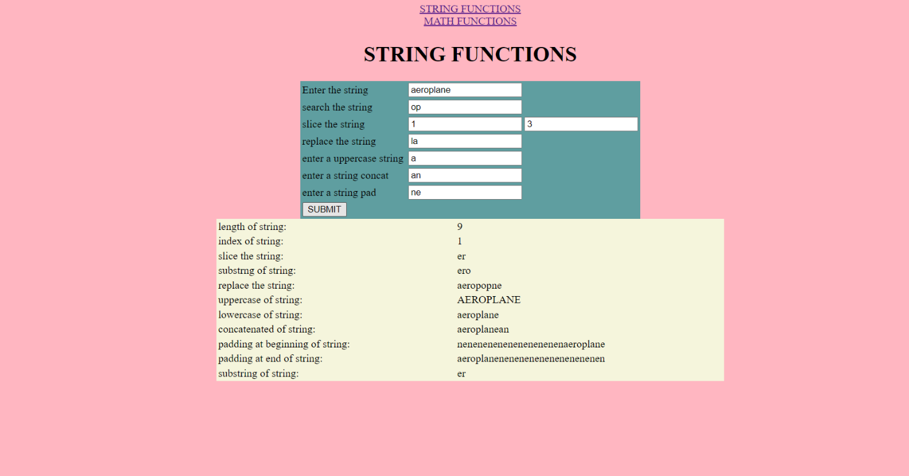

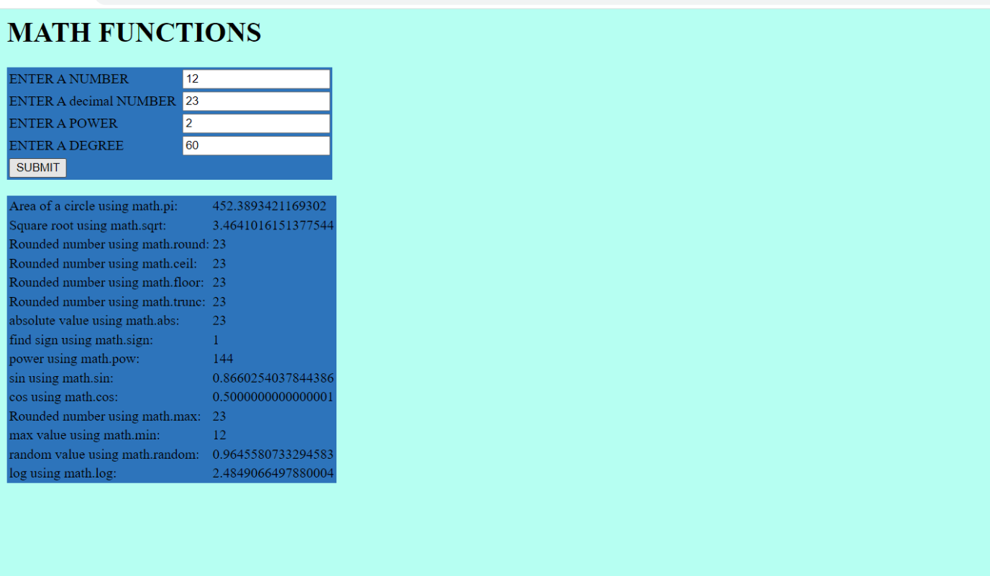**RESULT**:The program was successfully executed and output obtained successfully.

**PROGRAM NO:7**

**AIM:** Generate the calendar using JavaScript code by getting the year from the user*.*

**Design**: Create an HTML page for displaying calendar

**Source code**

|  |  |
| --- | --- |
| Calendar.html | <html>  <head>  <title>Calender</title>  <script>  function createCalendar(){  var year=Number(document.getElementById("year").value);  const months = [  "January",  "February",  "March",  "April",  "May",  "June",  "July",  "August",  "September",  "October",  "November",  "December",  ];  for(let mon=0;mon<12;++mon)  {  let d=new Date(year,mon);    let table=  months[mon]+  "<table border='5'><tr><th>SUN</th><th>MON</th><th>TUE</th><th>WED</th><th>THU</th><th>FRI</th><th>SAT</th></tr><tr>";  for(let i=0; i < d.getDay(); i++){  table +="<td></td>";  }  while(d.getMonth()==mon){  table+="<td>" +d.getDate()+ "</td>";    if (d.getDay() == 6) {  table += "</tr><tr>";  }  d.setDate(d.getDate() + 1);  }  if(d.getDay!=0){  for(let i=d.getDay();i<=6;i++){  table+="<td></td>";  }  }  table+="</tr></table>";  document.getElementById(mon).innerHTML = table;  }  }  </script>  </head>  <body>  <table align="center" >  <tr>  <td><div id="0"></div></td>  <td><div id="1"></div></td>  <td><div id="2"></div></td>  <td><div id="3"></div></td>  </tr>  <tr>  <td><div id="4"></div></td>  <td><div id="5"></div></td>  <td><div id="6"></div></td>  <td><div id="7"></div></td>  </tr>  <tr>  <td><div id="8"></div></td>  <td><div id="9"></div></td>  <td><div id="10"></div></td>  <td><div id="11"></div></td>  </tr>  </table>  Enter an year <input type="text" id="year">  <button onClick="createCalendar();">OK</button>  </body>  </html> |

**Output:**

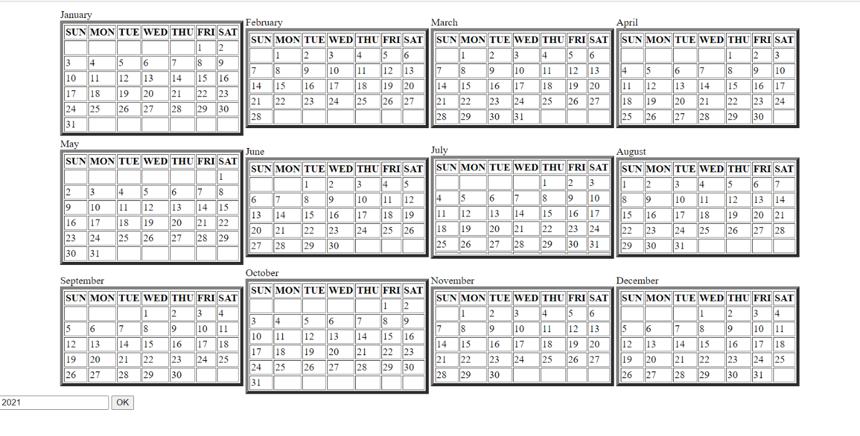

**RESULT**:

The program was successfully executed and output obtained successfully.

**PROGRAM NO:8**

**AIM:** Create a HTML registration form and to validate the form using JavaScript code.

**Design**: 1. Create an HTML form

2. Add validations to the form using JavaScript

3. Use CSS to style the page

**Source code**:

|  |  |
| --- | --- |
| Val.html | <html>  <head>    <title>validation form</title>  <style>  body{background-color: rgb(231, 255, 182);}  table{background-color: rgb(153, 119, 140);}  </style>  <script>  function submit(){  var name=document.getElementById("n").value;  var number=document.getElementById("num").value;  var password=document.getElementById("p").value;  var email=document.getElementById("e").value;  var pattern = /^[^ ]+@[^ ]+\$/;  if(name==null||name=="")  {  alert("Name can't be blank");  return false;  }  if(email.match(pattern))  {  alert("email only contain letters,digits and patterns");  return false;  }  if(number.length!=10)  {  alert("please enter Valid mobile number")  return false;  }    if(password.length<6)  {  alert("Password must be 6 character length");  return false;  }  }  </script>  </head>  <body>    <center>  <h1>VALIDATION FORM</h1>  <table>  <tr>  <td>username:</td>  <td><input type="text" name="name" id="n"></td>  </tr>  <tr>  <td>e-mail:</td>  <td><input type="e-mail" name="e-mail" id="e"></td>  </tr>  <tr>  <td>Mobile Number:</td>  <td><input type="mobile number" name="number" id="num"></td>  </tr>  <tr>  <td>DOB:</td>  <td><input type="date" name="date" id="d"></td>  </tr>  <tr>  <td>password:</td>  <td><input type="password" name="password" id="p"></td>  </tr>  <tr>  <td><button id="con" onclick="submit()">SUBMIT</button></td>  </tr>  </table>  </center>  </body>  </html> |

**Output:**

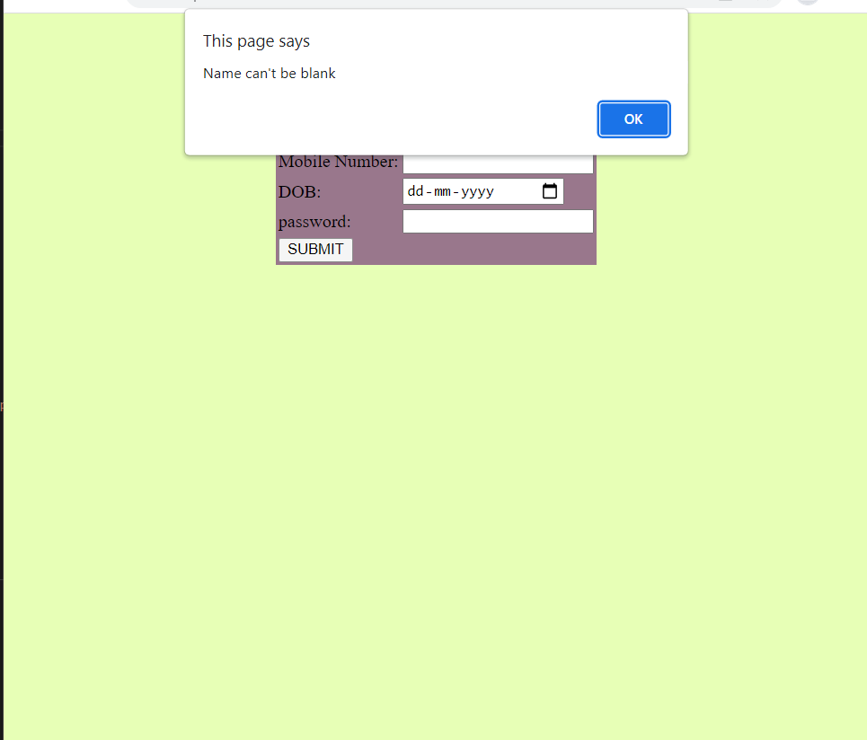

**RESULT**:

The program was successfully executed and output obtained successfully.

**PROGRAM NO:9**

**AIM:**. Evaluating JavaScript Event Handling for every click of a button to change the background color of a HTML page*.*

**Design**: 1. Create an HTML page with a button

2. Use JavaScript for change background colour

**Source code:**

|  |  |
| --- | --- |
| Color.html | <html>  <head>  <title>Background change</title>  </head>  <style>  .container{  width:100%;  height:100%;  text-align: center;  display: grid;  }  #btn{  margin:auto;  padding:1em;  border:3px solid black;  outline:none;  }  </style>  <body>  <div class="container">  <input id="btn" type="button" value="Change background">  </div>  <script>  document.getElementById("btn").addEventListener("click", colorchange);  function colorchange() {  (Math.random() * 10000000);  var color = '#' + Math.floor(Math.random() * 10000000).toString(16);  document.body.style.background = color;  }  </script>  </body>  </html> |

**Output:**

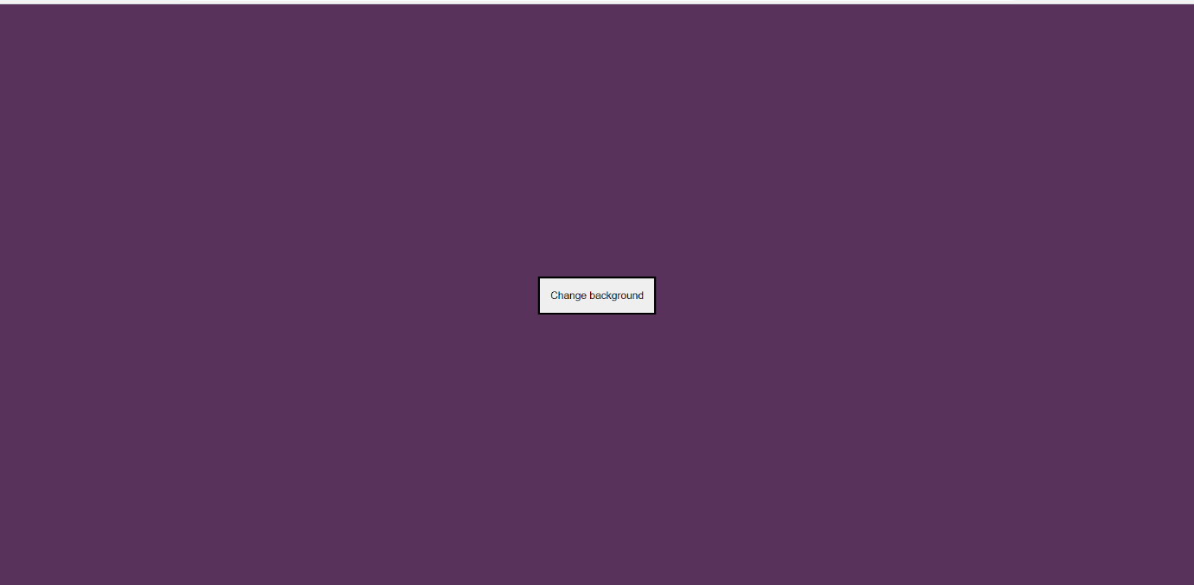

**RESULT**:

The program was successfully executed and output obtained successfully.

**PROGRAM NO:10**

**AIM:**. Create a HTML page to display a new image and text when the mouse comes over the existing content in the page using JavaScript Event Handling.

**Design**: 1. Create an HTML page containing questions

2. Use JavaScript for validation

**Source code:**

|  |  |
| --- | --- |
| Mouseover.html | <html>  <head>  <title>Image</title>  <style>    img{  background-repeat: no-repeat;  width: 100%;  height:100%;  }    </style>  </head>  <body>  <center>  <img src="image.JPG" id="image"><br><br>  <h1 id="heading1">Hover mouse here</h1>  <h1 id="heading2">hello world</h1>  <script>  document.getElementById("image").  addEventListener("mouseover",change1);  document.getElementById("image").  addEventListener("mouseout",change2);  document.getElementById("heading1").  addEventListener("mouseover",change1);  document.getElementById("heading1").  addEventListener("mouseout",change2);  function change1(){  document.getElementById('image').  src = "image2.JPG";  document.getElementById('heading1').  style.display="none";  }  function change2(){  document.getElementById('image').  src = "img2.JPG";  document.getElementById('heading1').  style.display="block";  }  </script>  </center>  </body>  </html> |

**Output:**



**RESULT**:

The program was successfully executed and output obtained successfully.

**PROGRAM NO:11**

**AIM:**. Create a HTML page to show online exam using JavaScript.

**Design**: 1. Create an HTML page containing questions

2. Use JavaScript for validation

**Source code:**

|  |  |
| --- | --- |
| Onlineexam.html | <html>  <head>  <script type="text/javascript">  var c=0;  var score=0;  function funct()  {  if(document.getElementById('javascript').checked)    {  score++;  }  if(document.getElementById('russia').checked)    {  score++;  }  if(document.getElementById('shanghai').checked)    {  score++;  }  if(document.getElementById('corona virus').checked)    {  score++;  }  document.write("your score is:");  document.write(score);    }  </script>  <link rel="stylesheet" href="quiz.css">  </head>  <body>  <form name="quiz">  <h1>QUIZ</h1>  <div>  <p>1.what is the best programming language to learn in 2021?</p>  <p><input type="radio" id="html" name="question1" value="A.HTML">A.HTML</p>  <p><input type="radio"id="python" name="question1" value="B.HTML">B.PYTHON</p>  <p><input type="radio" id="javascript" name="question1" value="C.HTML">C.JAVASCRIPT</p>  </div>  <div>  <p>2.which is the biggest country in the world?</p>  <p><input type="radio" id="russia" name="question2" value="A.country">A.RUSSIA</p>  <p><input type="radio" id="america" name="question2" value="B.country">B.AMERICA</p>  <p><input type="radio" id="china" name="question2" value="C.country">C.CHINA</p>  </div>  <div>  <p>3.what is the capital of china?</p>  <p><input type="radio" id="guanzhou" name="question3" value="A.capital">A.GUANZHOU</p>  <p><input type="radio" id="nanjini" name="question3" value="B.capital">B.NANJINI</p>  <p><input type="radio" id="shanghai" name="question3" value="C.capital">C.SHANGHAI</p>  </div>  <div>  <p>4.what is the biggest problem in the now?</p>  <p><input type="radio" id="financial problems" name="question4" value="A.problem">A.FINANCIAL PROBLEMS</p>  <p><input type="radio" id="corona virus" name="question4" value="B.problem">B.CORONA VIRUS</p>  <p><input type="radio" id="economic problems" name="question4" value="C.problrm">C.ECONOMIC PROBLEMS</p>  </div>  <button onclick="funct()">SUBMIT</button>  </form>    </body>  </html> |

|  |  |
| --- | --- |
| Style.css | body{  background-color: aquamarine;  color: black;  font-size: 20px;  font-weight: bolder;  margin-left: 2px;  }  #button{  background-color: black;  color: darkgray;  font-size: 18px;  padding: 5px;  } |

**Output:**



**RESULT**:

The program was successfully executed and output obtained successfully.

PHP

PHP (Hypertext Pre-processor) is a server-side scripting language designed for web development but also used as a general-purpose programming language. PHP is a widely used open-source general purpose scripting language that is especially suited for web development and can be embedded into HTML. Instead of lots of commands to output HTML, PHP pages contain HTML with embedded code that does something. The PHP code is enclosed in special start and end processing instructions that allow you to jump into and out of PHP mode. What distinguishes PHP from something like client-side java script is that the code is executed on the server, generating HTML which is ten sent to the client. The client would receive the results of running that script, but would not know what the underlying code was. You can even configure your web server to process your entire HTML file with PHP, and then there’s really no way that users can tell what you have up yourselves.

The best things in using PHP are that it is extremely simple for a newcomer, but offers many advanced features for a professional programmer. PHP is mainly focused on server-side scripting, so you can do anything any other CGI program can do, such as collect form data, generate dynamic page content, or send and receive cookies.

**MYSQL**

MySQL is an open-source relational database management system (RDBMS). A relational database organizes data into one or more data tables in which data types may be related to each other; these relations help structure the data. SQL is a language programmers use to create, modify and extract data from the relational database, as well as control user access to the database. In addition to relational databases and SQL, an RDBMS like MySQL works with an operating system to implement a relational database in a computer's storage system, manages users, allows for network access and facilitates testing database integrity and creation of backups.

MySQL is free and open-source software under the terms of the GNU General Public License, and is also available under a variety of proprietary licenses. MySQL was owned and sponsored by the Swedish company MySQL AB, which was bought by Sun Microsystems (now Oracle Corporation). In 2010, when Oracle acquired Sun, Widenius forked the opensource MySQL project to create MariaDB.

**PROGRAM NO:12**

**AIM:**. Develop a PHP program to connect to a database and retrieve data from a table and show the details in a neat format*.*

**Design**: 1. Create a page with extension .php for connecting database and to retrieve data from database

2. Use HTML table tag for displaying the result

**Source code:**

|  |  |
| --- | --- |
| db.php | <?php  $conn=mysqli_connect("localhost","root","","valiadation");  if($conn)  {  echo("connect successfully");  echo "<br>";  }  else{  echo("error");  echo"<br>";  }  if(isset($_POST["submit"]))  {  $flag=0;  $name=$_POST['name'];  $age=$_POST['age'];  $email=$_POST['email'];  $phone=$_POST['phone'];  $password=$_POST['password'];  $c1=preg_match('@[a-z]@',$password);  $c2=preg_match('@[A-Z]@',$password);  $c3=preg_match('@[0-9]@',$password);  $c4=preg_match('@[a-z]@',$name);  $c5=preg_match('@[A-Z]@',$name);  $c6= preg_match('@[6-9]\d{9}@', $phone);    if($name=="")  {  echo ("enter your name")."<br>";  $flag=1;  }  elseif(!$c4 || !$c5)  {  echo("only letters are allowed")."<br>";  $flag=1;  }  if($age=="")  {  echo ("enter your age")."<br>";  $flag=1;  }  if($phone=="")  {  echo ("enter your phone no")."<br>";  $flag=1;  }  elseif(!$c6)  {  echo("phone number must contain 10 digits and start with 6/7/8/9 digits")."<br>";  $flag=1;  }  if($email=="")  {  echo ("enter a email can't be blank")."<br>";  $flag=1;  }    if($password==""&& strlen($password<6))  {  echo (" enter a valid password")."<br>";  $flag=1;  }  elseif(!$c1 || !$c2 || !$c3)  {  echo("enter a valid password");  $flag=1;  }  if($flag==0)  {  $query="INSERT INTO val_table(name,age,email,phone,password) VALUES('$name','$age','$email','$phone','$password')";  if(mysqli_query($conn,$query))  {  echo("Sucessfully connected");  echo"<br>";  }  else  {  echo("inserton failed");  echo"<br>";  }}}  ?>  <html>  <head>  <style>  body{  background-color:violet;  }  table{    background-color:skyblue;  width: 500px;  padding: 50px;  margin: 100px;  }  div{  float:left;  align-items:center;  display:flex;  justify-content:center;  }  </style>  <title>validation form</title>  </head>  <body>  <form method="POST">  <h1><u>Registration FORM</u></h1>  <div>  <table>  <tr>  <th>name:</th>  <td><input type="text" name="name" id="n" placeholder="enter your name"></td>  </tr>  <th>Age:</th>  <td><input type="number" name="age" value="a" placeholder="enter your age"></td>  </tr>  <tr>  <th>email:</th>  <td><input type="text" name="email" id="e" placeholder="enter your mail"></td>  </tr>  <tr>  <th>phone:</th>  <td><input type="tel" name="phone" id="p" placeholder="enter your phone no:"></td>  </tr>  <tr>  <th>password</th>  <td><input type="password" name="password" id="p" placeholder="enter password:"></td>  </tr>  <tr>  <td><input type="submit" name="submit"></td>  </tr>  </table>  </form>  <table border="1">  <tr>  <th>Username</th>  <th>age</th>  <th>email</th>  <th>Phone</th>  <th>password</th>  </tr>  <?php  $s="SELECT * FROM val_table";  $data=mysqli_query($conn,$s);  while($res=mysqli_fetch_array($data))  {  ?>  <tr>  <td><?php echo $res['name'];?></td>  <td><?php echo $res['age'];?></td>  <td><?php echo $res['email'];?></td>  <td><?php echo $res['phone'];?></td>  <td><?php echo $res['password'];?></td>  </tr>  <?php  }  ?>  </table>  </div>  </body>  </html> |

**Output:**

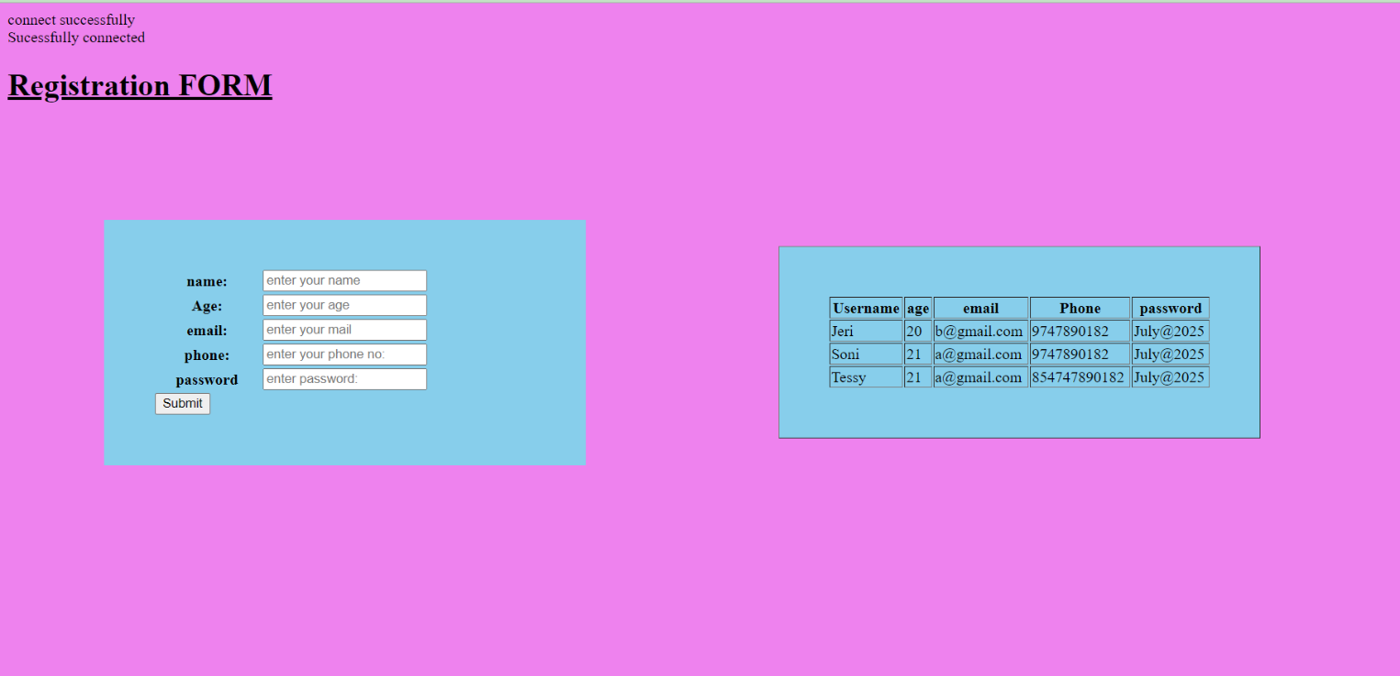

**RESULT**:

The program was successfully executed and output obtained successfully.

**PROGRAM NO:13**

**AIM:** Outline a registration form using PHP and do necessary validations.

**Design**: 1. Create an HTML page containing fields for registration

2. Use PHP for validations

**Source code:**

|  |  |
| --- | --- |
| Valiada.html | <?php  $conn=mysqli_connect("localhost","root","","valiadation");  if($conn)  {  echo("connect successfully");  echo "<br>";  }  else{  echo("error");  echo"<br>";  }  if(isset($_POST["submit"]))  {  $flag=0;  $name=$_POST['name'];  $age=$_POST['age'];  $email=$_POST['email'];  $phone=$_POST['phone'];  $password=$_POST['password'];  $c1=preg_match('@[a-z]@',$password);  $c2=preg_match('@[A-Z]@',$password);  $c3=preg_match('@[0-9]@',$password);  $c4=preg_match('@[a-z]@',$name);  $c5=preg_match('@[A-Z]@',$name);  $c6= preg_match('@[6-9]\d{9}@', $phone);    if($name=="")  {  echo ("enter your name")."<br>";  $flag=1;  }  elseif(!$c4 || !$c5)  {  echo("only letters are allowed")."<br>";  $flag=1;  }  if($age=="")  {  echo ("enter your age")."<br>";  $flag=1;  }  if($phone=="")  {  echo ("enter your phone no")."<br>";  $flag=1;  }  elseif(!$c6)  {  echo("phone number must contain 10 digits and start with 6/7/8/9 digits")."<br>";  $flag=1;  <html>  <head>  <style>  body{  background-color:pink;  }  table{    background-color:skyblue;  width: 500px;  padding: 50px;  margin: 100px;  }  </style>  <title>validation form</title>  </head>  <body>  <form method="POST">  <table>  <h1><u>Registration FORM</u></h1>  <tr>  <th>name:</th>  <td><input type="text" name="name" id="n" placeholder="enter your name"></td>  </tr>  <th>Age:</th>  <td><input type="number" name="age" value="a" placeholder="enter your age"></td>  </tr>  <tr>  <th>email:</th>  <td><input type="text" name="email" id="e" placeholder="enter your mail"></td>  </tr>  <tr>  <th>phone:</th>  <td><input type="phone no" name="phone" id="p" placeholder="enter your phone no:"></td>  </tr>  <tr>  <th>password</th>  <td><input type="password" name="password" id="p" placeholder="enter password:"></td>  </tr>  <tr>  <td><input type="submit" name="submit"></td>  </tr>  </table>  </form>  </body>  </html>  <?php  if(isset($_POST["submit"]))  {  $name=$_POST['name'];  $age=$_POST['age'];  $email=$_POST['email'];  $phone=$_POST['phone'];  $password=$_POST['password'];  $c1=preg_match('@[a-z]@',$password);  $c2=preg_match('@[A-Z]@',$password);  $c3=preg_match('@[0-9]@',$password);  $c4=preg_match('@[a-z]@',$name);  $c5=preg_match('@[A-Z]@',$name);  $c6= preg_match('@[6-9]\d{9}@', $phone);  if($name=="")  {  echo ("enter your name")."<br>";  }  elseif(!$c4 || !$c5)  {  echo("only letters are allowed")."<br>";  }  if($age=="")  {  echo ("enter your age")."<br>";  }  if($phone=="")  {  echo ("enter your phone no")."<br>";  }  elseif(!$c6)  {  echo("phone number must contain 10 digits and start with 6/7/8/9 digits")."<br>";  }  if($email=="")  {  echo ("enter a email can't be blank")."<br>";  }    if($password==""&& strlen($password<6))  {  echo (" enter a valid password")."<br>";  }  elseif(!$c1 || !$c2 || !$c3)  {  echo("enter a valid password");  }  }  ?> |

**Output:**

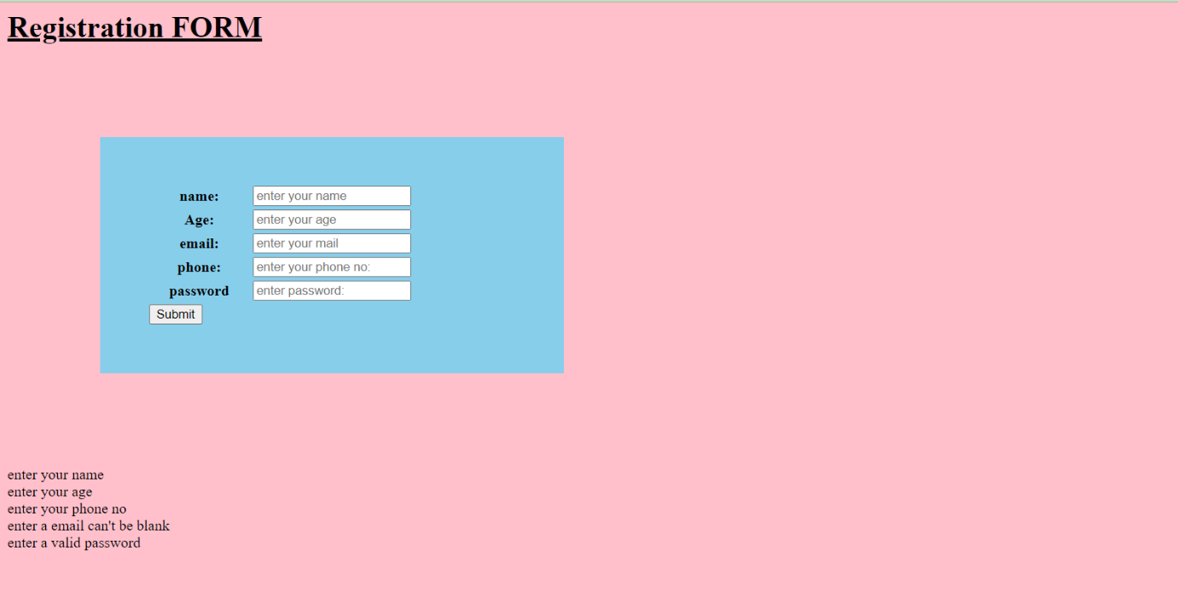

**RESULT**:

The program was successfully executed and output obtained successfully.

**PROGRAM NO:14**

**AIM:** Compose Electricity bill from user input based on a given tariff using PHP*.*

**Design**: 1. Create an HTML page containing form for entering bill details

2. Use PHP for calculation

**Source code:**

|  |  |
| --- | --- |
| Electricitybill.html | <html>  <head>  <style>  table{    background-color:pink;  width: 500px;  padding: 100px;  margin: 100px;      }  </style>  </head>  <body>  <form method="POST">  <table>  <tr>  <td>Enter the meter number:  <input type="number" name="number" value="" >  </td>  </tr>  <tr>  <td>Enter the number of units:  <input type="number" name="unit" value="" >  </td>  </tr>  <tr>  <td>Enter the category:  <select name="tariff" >  <option>select</option>  <option value="Rural">Rural</option>  <option value="Residential">Residential</option>  <option value="Commercial">Commercial</option>  </select>  </td>  </tr>  <tr>  <td><input type="submit" name="submit" value="submit"/></td>  </tr>  </table>  </body>  </html>  <?php  if(isset($_POST['submit']))  {  $number=$_POST['number'];  $unit=$_POST['unit'];  $tariff=$_POST['tariff'];  if($tariff=="Rural")  {  if($unit>0&&$unit<=50)  {  $e=20;  $price=(($unit* .25)+$e);    }  else if($unit>50&&$unit<=100)  {  $e=25;  $price=(($unit* .55)+$e);  }  else if($unit>100&&$unit<=150)  {  $e=30;  $price=(($unit* .5)+$e);  }  else if($unit>150&&$unit<=250)  {  $e=35;  $price=(($unit* .2)+$e);    }  else if($unit>250&&$unit<=400)  {  $e=40;  $price=(($unit* .4)+$e);    }  else if($unit>400)  {  $e=45;  $price=(($unit* .3)+$e);  }  }  if($tariff=="Residential")  {  if($unit>0&&$unit<=50)  {  $e=30;  $price=(($unit* .35)+$e);    }  else if($unit>50&&$unit<=100)  {  $e=30;  $price=(($unit* .75)+$e);    }  else if($unit>100&&$unit<=150)  {  $e=30;  $price=(($unit* .35)+$e);    }  else if($unit>150&&$unit<=250)  {  $e=40;  $price=(($unit* .75)+$e);    }  else if($unit>250&&$unit<=400)  {  $e=40;  $price=(($unit* .75)+$e);  }  else if($unit>400)  {  $e=40;  $price=(($unit* .35)+$e);  }  }  if($tariff=="Commercial")  {  if($unit>0&&$unit<=50)  {  $e=30;  $price=(($unit* .35)+$e);  }  else if($unit>50&&$unit<=100)  {  $e=35;  $price=(($unit* .75)+$e);  }  else if($unit>100&&$unit<=150)  {  $e=40;  $price=(($unit* .35)+$e);  }  else if($unit>150&&$unit<=250)  {  $e=45;  $price=(($unit* .75)+$e);  }  else if($unit>250&&$unit<=400)  {  $e=50;  $price=(($unit* .75)+$e);  }  else if($unit>400)  {  $e=55;  $price=(($unit* .35)+$e);  }  }  echo "meter number:". $number;  echo"<br>";  echo "units:". $unit;  echo"<br>";  echo "category is:" .$tariff;  echo"<br>";  echo "extra charge:". $e;  echo"<br>";  echo "Total $unit units of charges". $price;  echo "<br>";  }  ?> |

Output:

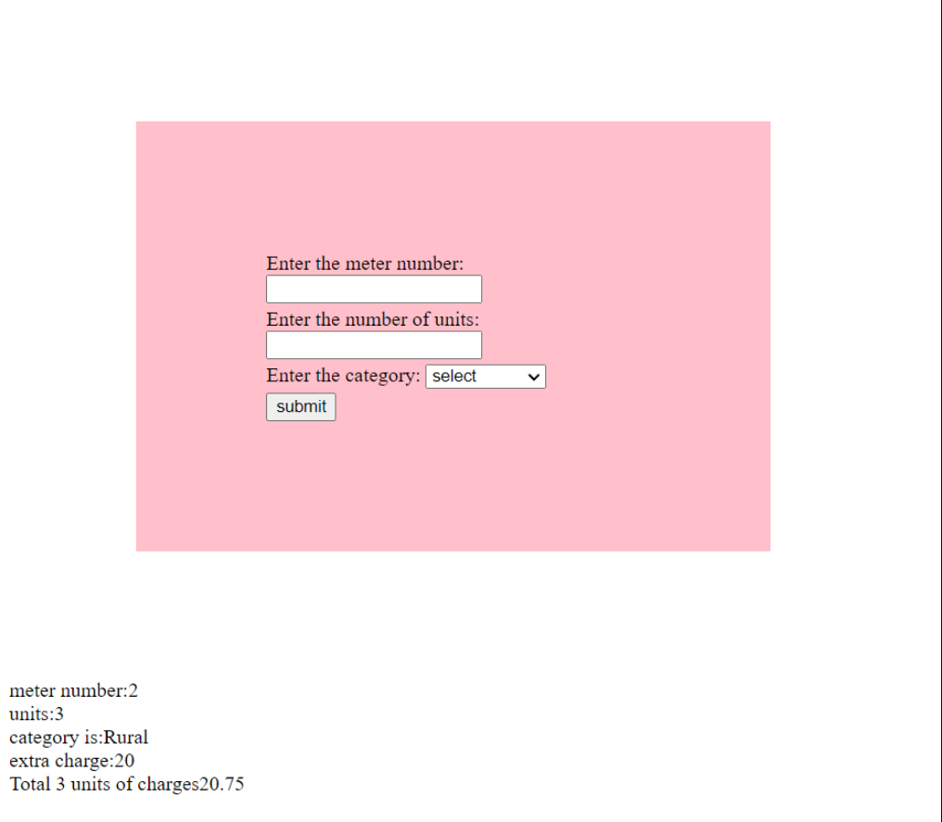

**RESULT**:

The program was successfully executed and output obtained successfully.

**PROGRAM NO:15**

**AIM:** Build a PHP code to store name of students in an array and display it using print_r function. Sort and Display the same using asort & arsort functions.

**Design**: 1. Create a page with extension .php

2. Use PHP to store names of students and display the data using print_r function

**Source code:**

|  |  |
| --- | --- |
| Students.php | <html>  <head>  </head>  <body>  <?php  $name=array("anu","tessy","jefri","jeri","catherine","kevin");  echo"Array:";  print_r($name);  echo"<br>"."Array in ascending order:";  asort($name);  print_r($name);  echo"<br>"."Array in descending order:";  arsort($name);  print_r($name);  ?>  </body>  </html> |

Output:

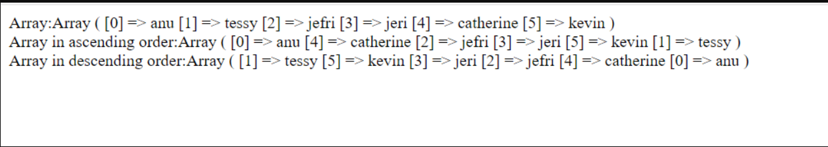

**RESULT**:The program was successfully executed and output obtained successfully.

**PROGRAM NO:16**

**AIM:** Build a PHP code to store name of Indian Cricket players in an array and display the same in HTML table*.*

**Design**: 1. Create a page with extension .php

2. Use PHP to store names of Indian Cricket

3. Display the stored details using table tags

**Source code:**

|  |  |
| --- | --- |
| Players.php | <html>  <body>  <?php  $players=array("Dhoni","Kholi",  "Ashwin","Sachin","Sanju","Malinga","Rahul");  echo "<table border='2'><tr><th>SL.NO.</th><th>PLAYERS</th></tr>";  foreach($players as $key=>$value)  {  echo"<tr><td>". $key."</td><th>$value</th></tr>";  }  echo "</table>";  ?>  </body>  </html> |

**Output:**

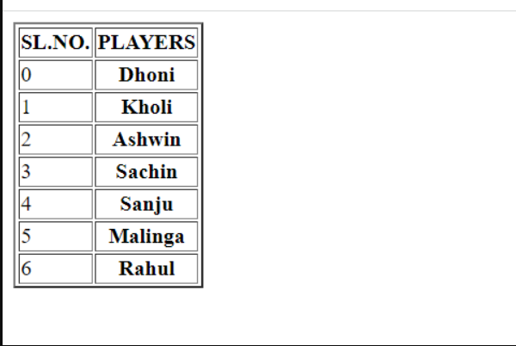

**RESULT**:

The program was successfully executed and output obtained successfully

**PROGRAM NO:18**

**AIM*:***Using PHP and MySQL, develop a program to accept book information viz. Accession number, title, authors, edition and publisher from a web page and store the information in a database and to search for a book with the title specified by the user and to display the search results with proper headings.

**Design**: 1. Create an HTML page with form for reading data from using

2. Use PHP to connect to database and store data

3. Display the details of book with specific title using table tags

**Source code:**

|  |  |
| --- | --- |
| Book.php | <?php  $con=mysqli_connect("localhost","root","","book");  if(mysqli_connect_errno())  {  printf("connection failed",mysqli_connect_error());  echo"<br>";  }  else  {  echo("connection successfull");  echo"<br>";  }  ?>  <html>  <head>  <style>  body{  background-color:lavender;  }  h2{  color:red;  }  table{  background-color:pink;  padding: 30px;  width: 1px;  border:black;  }  </style>  <title>book</title>  </head>  <body>  <form method="POST">  <center>  <table>  <h2><u>BOOK INFO:</u></h2>  <tr>  <th>accessionenumber:</th>  <td><input type="number" name="number"  id="n" placeholder="enter your book id"></td>  </tr>  <th>title:</th>  <td><input type="text" name="title" id="t"  placeholder="enter book title"></td>  </tr>  <tr>  <th>author:</th>  <td><input type="text" name="authors  " id="n"  placeholder="enter author's name"></td>  </tr>  <tr>  <th>edition:</th>  <td><input type="number" name="edition” id="n"  placeholder="enter edition"></td>  </tr>  <tr>  <th>publisher:</th>  <td><input type="text" name="publisher" id="n"  placeholder="enter name of publisher"></td>  </tr>  <tr>  <td><input type="submit" name="submit" value="submit"></td>  </tr>  </table>  </center>  </form>  <form action="" method="POST">  <center>  <h3><u>SEARCH THE BOOK</u></h3>  <table>  <tr>  <td>Enter the title  <input type="name" name="title" id="t"  placeholder="search the book"></td>  </tr>  <tr>  <td><input type="submit" name="search" value="search"></td>  </tr>  </table>  </center>  </form>    <?php    if(isset($_POST["submit"]))  {  $number=$_POST['number'];  $title=$_POST['title'];  $authors=$_POST['authors'];  $edition=$_POST['edition'];  $publisher=$_POST['publisher'];    $query="INSERT INTO book_table(accessionnumber  ,title,authors,edition,  publisher)VALUES('{$number}','{$title}','{$authors}','{$edition}'  ,'{$publisher}')";  if(mysqli_query($con,$query))  {  echo("successfully connected");  echo"<br>";  }  else  {  echo(mysqli_error($con));  echo("connection failed");  echo"<br>";  }    }  if(isset($_POST["search"]))  {  $title=$_POST['title'];  $search="SELECT * FROM book_table  WHERE title Like '%$title%'";  $data=mysqli_query($con,$search);  echo'<table border=1 align="left"padding="25%"> <tr><th>accessionnumber</th><th>title</th><th>autho  r</th><th>edition</th><th>publisher</th></tr>';  while($res=mysqli_fetch_assoc($data))  {    echo'<tr>';  echo'<td>';  echo $res['accessionnumber'];  echo'</td>';  echo'<td>';  echo $res['title'];  echo'</td>';  echo'<td>';  echo $res['authors'];  echo'</td>';  echo'<td>';  echo $res['edition'];  echo'</td>';  echo'<td>';  echo $res['publisher'];  echo'</td></tr>';  }  echo'</table>';  }  ?>  </body>  </html> |

**Output:**

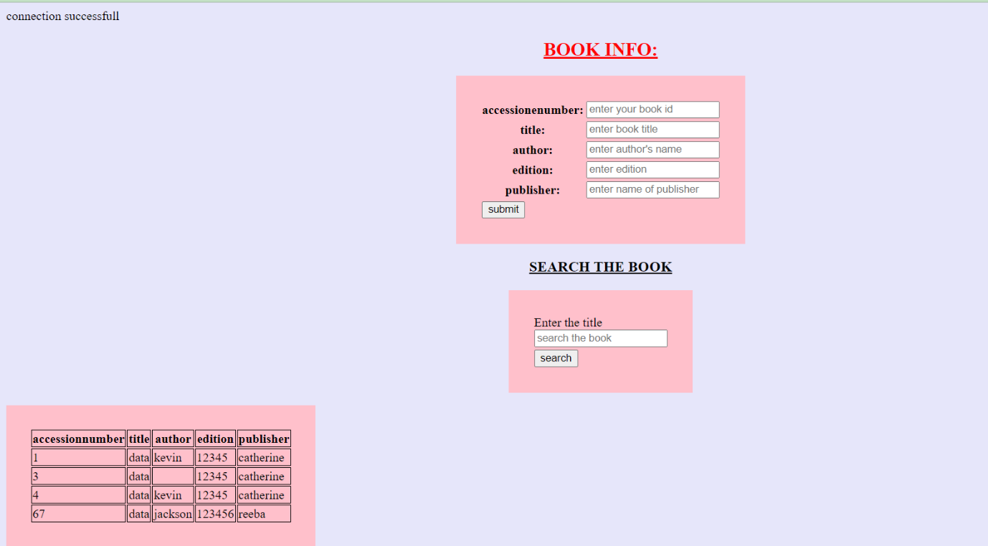

**RESULT:**

The program was successfully executed and output obtained successfully.

**PROGRAM NO:18**

**AIM*:*** Develop a web application for Airline Reservation System using any PHP framework (Laravel, CodeIgniter, Symfony, CakePHP etc.).

**Design**:

**Source code:**

|  |  |
| --- | --- |
|  | ****Controller*****  <?php  defined('BASEPATH') OR exit('No direct script access allowed');    class Login extends CI_Controller {    public function index()  {  $this->load->view('login_view');  }  public function process()  {  $user = $this->input->post('user');  $pass = $this->input->post('pass');  $this->load->model('Login_model');  $validate=$this->Login_model->index($user,$pass);  if($validate){  //declaring session  //$this->session->set_userdata(array('user'=>$user));  $this->load->view('welcome_view');  }  else{  $data['error'] = 'Your Account is Invalid';  $this->load->view('login_view', $data);  }  // if ($user=='juhi' && $pass=='123')  // {  // //declaring session  // //$this->session->set_userdata(array('user'=>$user));  // $this->load->view('welcome_view');  // }  // else{  // $data['error'] = 'Your Account is Invalid';  // $this->load->view('login_view', $data);  // }  }  public function logout()  {  //removing session  $this->session->unset_userdata('user');  redirect("Login");  }    }  ?>  ***View****  <!DOCTYPE html>  <html>  <head>  <title>Login Page</title>  </head>  <body>  <?php echo isset($error) ? $error : ''; ?>  <form method="post" action="Login/process">  <table cellpadding="2" cellspacing="2">  <tr>  <td><th>Username:</th></td>  <td><input type="text" name="user"></td>  </tr>  <tr>  <td><th>Password:</th></td>  <td><input type="password" name="pass"></td>  </tr>    <tr>  <td> </td>  <td><input type="submit" value="Login"></td>  </tr>  </table>  </form>  </body>  </html>  ***welcome_view***  <!DOCTYPE html>  <html>  <head>  <title></title>  </head>  <body>  Welcome  <br>        </body>  </html>  **** Model****  <?php  defined('BASEPATH') OR exit('No direct script access allowed');  class Login_Model extends CI_Model{  public function index($user,$password){  $this->load->database();  $data=array(  'username'=>$user,  'pass'=>$password);  $query=$this->db->where($data);  $login=$this->db->get('tb_login');  if($login!=NULL){  return $login->row();  }  }} |

**Output:**

**RESULT:**

The program was successfully executed and output obtained successfully.